**HOW TO FIND PASSWORDS USING WIRESHARK**

## **Step 1: Downloading Wireshark to Your CPU**

## **Step 2: How You Know a Website Uses HTTPS**

**the information in HTTPS packets because some bright people found it useful to protect this information and this is a good thing. Major websites all have encrypted packets and it would be foolish to bother with them, especially if the only thing you have read is this how to. Above are some websites that use HTTPS and you know this because there is a little green lock and the website starts with HTTPS not HTTP.**

## **Step 3: Finding a Password**

**First one must identify an unprotected website and make a log on attempt - either successful or unsuccessful. It is VERY IMPORTANT that you click the capture button in the upper left corner of wire shark and have it run while you make the logon attempt. In the second step we will follow this packet and track it down using wire shark.**

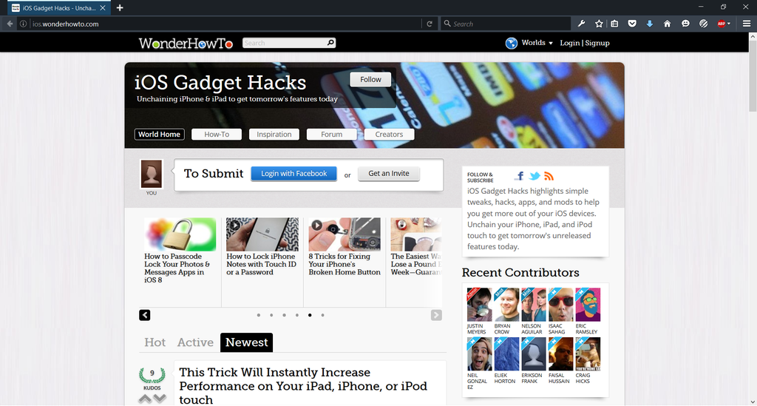

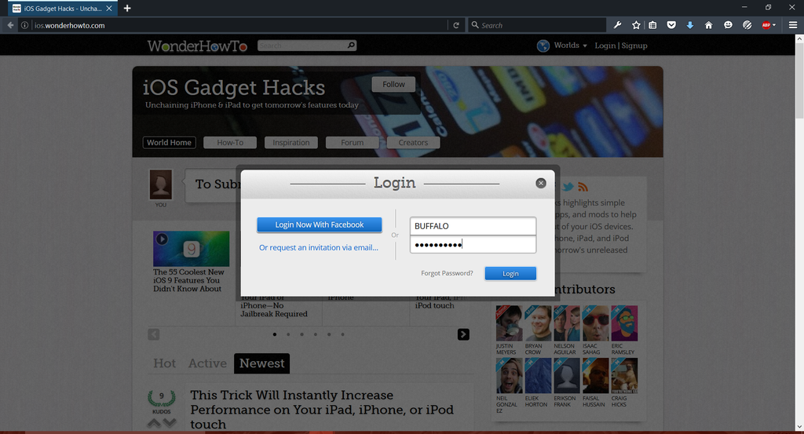

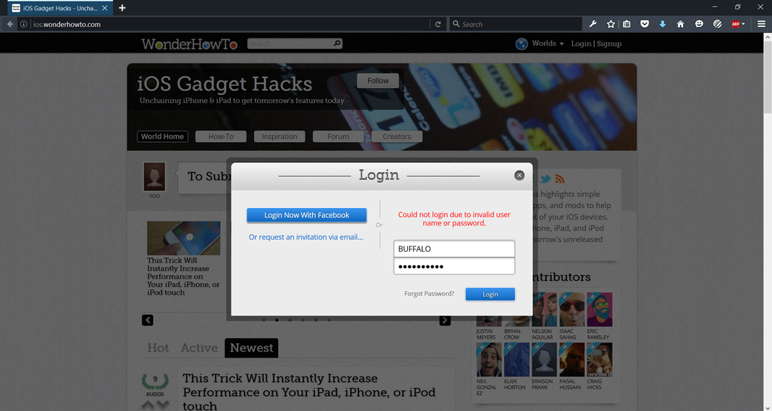

## **Step 6: Finding a Password (Continued)**

**The second step to finding the packets that contain login information is to understand the protocol to look for. HTTP is the protocol we will be dealing with when looking for passwords. Wireshark comes with the option to filter packets. In the filter box type "http.request.method == POST". By filtering this you are now only looking at the post packet for HTTP. This drastically narrows the search and helps to slow down the traffic by minimizing what pops up on the screen. Then at the far right of the packet in the info section you will see something like ".login" or "/login". You can see exactly what I am talking about if you follow the pictures above. Then you will right click on it and go down to "FOLLOW" then to "TCP STREAM". Once you get there look in the red text paragraphs and try to find what I was able to locate in the picture. And you have just located the password and username you have entered on the unprotected login page - whether or not the password and username are correct are irrelevant.**

